**Apex Specialist Superbadge**

**1. Automate record creation**

**(i) MaintenanceRequestHelper Class :-**

public with sharing class MaintenanceRequestHelper {

public static void updateworkOrders(List<Case> updWorkOrders, Map<Id,Case> nonUpdCaseMap) {

Set<Id> validIds = new Set<Id>();

For (Case c : updWorkOrders){

if (nonUpdCaseMap.get(c.Id).Status != 'Closed' && c.Status == 'Closed'){

if (c.Type == 'Repair' || c.Type == 'Routine Maintenance'){

validIds.add(c.Id);

}

}

}

if (!validIds.isEmpty()){

List<Case> newCases = new List<Case>();

Map<Id,Case> closedCasesM = new Map<Id,Case>([SELECT Id, Vehicle__c, Equipment__c, Equipment__r.Maintenance_Cycle__c,(SELECT Id,Equipment__c,Quantity__c FROM Equipment_Maintenance_Items__r)

FROM Case WHERE Id IN :validIds]);

Map<Id,Decimal> maintenanceCycles = new Map<ID,Decimal>();

AggregateResult[] results = [SELECT Maintenance_Request__c, MIN(Equipment__r.Maintenance_Cycle__c)cycle FROM Equipment_Maintenance_Item__c WHERE Maintenance_Request__c IN :ValidIds GROUP BY Maintenance_Request__c];

for (AggregateResult ar : results){

maintenanceCycles.put((Id) ar.get('Maintenance_Request__c'), (Decimal) ar.get('cycle'));

}

for(Case cc : closedCasesM.values()){

Case nc = new Case (

ParentId = cc.Id,

Status = 'New',

Subject = 'Routine Maintenance',

Type = 'Routine Maintenance',

Vehicle__c = cc.Vehicle__c,

Equipment__c =cc.Equipment__c,

Origin = 'Web',

Date_Reported__c = Date.Today()

);

If (maintenanceCycles.containskey(cc.Id)){

nc.Date_Due__c = Date.today().addDays((Integer) maintenanceCycles.get(cc.Id));

} else {

nc.Date_Due__c = Date.today().addDays((Integer) cc.Equipment__r.maintenance_Cycle__c);

}

newCases.add(nc);

}

insert newCases;

List<Equipment_Maintenance_Item__c> clonedWPs = new List<Equipment_Maintenance_Item__c>();

for (Case nc : newCases){

for (Equipment_Maintenance_Item__c wp : closedCasesM.get(nc.ParentId).Equipment_Maintenance_Items__r){

Equipment_Maintenance_Item__c wpClone = wp.clone();

wpClone.Maintenance_Request__c = nc.Id;

ClonedWPs.add(wpClone);

}

}

insert ClonedWPs;

}

}

}

**(ii) MaintenanceRequest Trigger :-**

trigger MaintenanceRequest on Case (before update, after update) {

if(Trigger.isUpdate && Trigger.isAfter){

MaintenanceRequestHelper.updateWorkOrders(Trigger.New,Trigger.OldMap);

}

}

**2. Synchronize Salesforce data with an external system**

**(i) WarehouseCalloutService Class :-**

public with sharing class WarehouseCalloutService implements Queueable {

private static final String WAREHOUSE_URL = 'https://th-superbadge-apex.herokuapp.com/equipment';

//class that makes a REST callout to an external warehouse system to get a list of equipment that needs to be updated.

//The callout’s JSON response returns the equipment records that you upsert in Salesforce.

@future(callout=true)

public static void runWarehouseEquipmentSync(){

Http http = new Http();

HttpRequest request = new HttpRequest();

request.setEndpoint(WAREHOUSE_URL);

request.setMethod('GET');

HttpResponse response = http.send(request);

List<Product2> warehouseEq = new List<Product2>();

if (response.getStatusCode() == 200){

List<Object> jsonResponse = (List<Object>)JSON.deserializeUntyped(response.getBody());

System.debug(response.getBody());

//class maps the following fields: replacement part (always true), cost, current inventory, lifespan, maintenance cycle, and warehouse SKU

//warehouse SKU will be external ID for identifying which equipment records to update within Salesforce

for (Object eq : jsonResponse){

Map<String,Object> mapJson = (Map<String,Object>)eq;

Product2 myEq = new Product2();

myEq.Replacement_Part__c = (Boolean) mapJson.get('replacement');

myEq.Name = (String) mapJson.get('name');

myEq.Maintenance_Cycle__c = (Integer) mapJson.get('maintenanceperiod');

myEq.Lifespan_Months__c = (Integer) mapJson.get('lifespan');

myEq.Cost__c = (Integer) mapJson.get('cost');

myEq.Warehouse_SKU__c = (String) mapJson.get('sku');

myEq.Current_Inventory__c = (Double) mapJson.get('quantity');

myEq.ProductCode = (String) mapJson.get('_id');

warehouseEq.add(myEq);

}

if (warehouseEq.size() > 0){

upsert warehouseEq;

System.debug('Your equipment was synced with the warehouse one');

}

}

}

public static void execute (QueueableContext context){

runWarehouseEquipmentSync();

}

}

**(ii) WarehouseSyncSchedule Class :-**

global with sharing class WarehouseSyncSchedule implements Schedulable{

global void execute(SchedulableContext ctx){

System.enqueueJob(new WarehouseCalloutService());

}

}

**(iii) Anonymous Window :-**

System.enqueueJob(new WarehouseCalloutService());

**3. Schedule synchronization**

**(i) WarehouseSyncSchedule Class :-**

global with sharing class WarehouseSyncSchedule implements Schedulable{

global void execute(SchedulableContext ctx){

System.enqueueJob(new WarehouseCalloutService());

}

}

**4. Test automation logic**

**(i) MaintenanceRequest Trigger :-**

trigger MaintenanceRequest on Case (before update, after update) {

if(Trigger.isUpdate && Trigger.isAfter){

MaintenanceRequestHelper.updateWorkOrders(Trigger.New, Trigger.OldMap);

}

}

**(ii) MaintenanceRequestHelper Class :-**

public with sharing class MaintenanceRequestHelper {

public static void updateworkOrders(List<Case> updWorkOrders, Map<Id,Case> nonUpdCaseMap) {

Set<Id> validIds = new Set<Id>();

For (Case c : updWorkOrders){

if (nonUpdCaseMap.get(c.Id).Status != 'Closed' && c.Status == 'Closed'){

if (c.Type == 'Repair' || c.Type == 'Routine Maintenance'){

validIds.add(c.Id);

}

}

}

if (!validIds.isEmpty()){

List<Case> newCases = new List<Case>();

Map<Id,Case> closedCasesM = new Map<Id,Case>([SELECT Id, Vehicle__c, Equipment__c, Equipment__r.Maintenance_Cycle__c,(SELECT Id,Equipment__c,Quantity__c FROM Equipment_Maintenance_Items__r)

FROM Case WHERE Id IN :validIds]);

Map<Id,Decimal> maintenanceCycles = new Map<ID,Decimal>();

AggregateResult[] results = [SELECT Maintenance_Request__c, MIN(Equipment__r.Maintenance_Cycle__c)cycle FROM Equipment_Maintenance_Item__c WHERE Maintenance_Request__c IN :ValidIds GROUP BY Maintenance_Request__c];

for (AggregateResult ar : results){

maintenanceCycles.put((Id) ar.get('Maintenance_Request__c'), (Decimal) ar.get('cycle'));

}

for(Case cc : closedCasesM.values()){

Case nc = new Case (

ParentId = cc.Id,

Status = 'New',

Subject = 'Routine Maintenance',

Type = 'Routine Maintenance',

Vehicle__c = cc.Vehicle__c,

Equipment__c =cc.Equipment__c,

Origin = 'Web',

Date_Reported__c = Date.Today()

);

If (maintenanceCycles.containskey(cc.Id)){

nc.Date_Due__c = Date.today().addDays((Integer) maintenanceCycles.get(cc.Id));

}

newCases.add(nc);

}

insert newCases;

List<Equipment_Maintenance_Item__c> clonedWPs = new List<Equipment_Maintenance_Item__c>();

for (Case nc : newCases){

for (Equipment_Maintenance_Item__c wp : closedCasesM.get(nc.ParentId).Equipment_Maintenance_Items__r){

Equipment_Maintenance_Item__c wpClone = wp.clone();

wpClone.Maintenance_Request__c = nc.Id;

ClonedWPs.add(wpClone);

}

}

insert ClonedWPs;

}

}

}

**(iii) MaintenanceRequestHelperTest Class :-**

@istest

public with sharing class MaintenanceRequestHelperTest {

private static final string STATUS_NEW = 'New';

private static final string WORKING = 'Working';

private static final string CLOSED = 'Closed';

private static final string REPAIR = 'Repair';

private static final string REQUEST_ORIGIN = 'Web';

private static final string REQUEST_TYPE = 'Routine Maintenance';

private static final string REQUEST_SUBJECT = 'Testing subject';

PRIVATE STATIC Vehicle__c createVehicle(){

Vehicle__c Vehicle = new Vehicle__C(name = 'SuperTruck');

return Vehicle;

}

PRIVATE STATIC Product2 createEq(){

product2 equipment = new product2(name = 'SuperEquipment',

lifespan_months__C = 10,

maintenance_cycle__C = 10,

replacement_part__c = true);

return equipment;

}

PRIVATE STATIC Case createMaintenanceRequest(id vehicleId, id equipmentId){

case cs = new case(Type=REPAIR,

Status=STATUS_NEW,

Origin=REQUEST_ORIGIN,

Subject=REQUEST_SUBJECT,

Equipment__c=equipmentId,

Vehicle__c=vehicleId);

return cs;

}

PRIVATE STATIC Equipment_Maintenance_Item__c createWorkPart(id equipmentId,id requestId){

Equipment_Maintenance_Item__c wp = new Equipment_Maintenance_Item__c(Equipment__c = equipmentId,

Maintenance_Request__c = requestId);

return wp;

}

@istest

private static void testMaintenanceRequestPositive(){

Vehicle__c vehicle = createVehicle();

insert vehicle;

id vehicleId = vehicle.Id;

Product2 equipment = createEq();

insert equipment;

id equipmentId = equipment.Id;

case somethingToUpdate = createMaintenanceRequest(vehicleId,equipmentId);

insert somethingToUpdate;

Equipment_Maintenance_Item__c workP = createWorkPart(equipmentId,somethingToUpdate.id);

insert workP;

test.startTest();

somethingToUpdate.status = CLOSED;

update somethingToUpdate;

test.stopTest();

Case newReq = [Select id, subject, type, Equipment__c, Date_Reported__c, Vehicle__c, Date_Due__c

from case

where status =:STATUS_NEW];

Equipment_Maintenance_Item__c workPart = [select id

from Equipment_Maintenance_Item__c

where Maintenance_Request__c =:newReq.Id];

system.assert(workPart != null);

system.assert(newReq.Subject != null);

system.assertEquals(newReq.Type, REQUEST_TYPE);

SYSTEM.assertEquals(newReq.Equipment__c, equipmentId);

SYSTEM.assertEquals(newReq.Vehicle__c, vehicleId);

SYSTEM.assertEquals(newReq.Date_Reported__c, system.today());

}

@istest

private static void testMaintenanceRequestNegative(){

Vehicle__C vehicle = createVehicle();

insert vehicle;

id vehicleId = vehicle.Id;

product2 equipment = createEq();

insert equipment;

id equipmentId = equipment.Id;

case emptyReq = createMaintenanceRequest(vehicleId,equipmentId);

insert emptyReq;

Equipment_Maintenance_Item__c workP = createWorkPart(equipmentId, emptyReq.Id);

insert workP;

test.startTest();

emptyReq.Status = WORKING;

update emptyReq;

test.stopTest();

list<case> allRequest = [select id

from case];

Equipment_Maintenance_Item__c workPart = [select id

from Equipment_Maintenance_Item__c

where Maintenance_Request__c = :emptyReq.Id];

system.assert(workPart != null);

system.assert(allRequest.size() == 1);

}

@istest

private static void testMaintenanceRequestBulk(){

list<Vehicle__C> vehicleList = new list<Vehicle__C>();

list<Product2> equipmentList = new list<Product2>();

list<Equipment_Maintenance_Item__c> workPartList = new list<Equipment_Maintenance_Item__c>();

list<case> requestList = new list<case>();

list<id> oldRequestIds = new list<id>();

for(integer i = 0; i < 300; i++){

vehicleList.add(createVehicle());

equipmentList.add(createEq());

}

insert vehicleList;

insert equipmentList;

for(integer i = 0; i < 300; i++){

requestList.add(createMaintenanceRequest(vehicleList.get(i).id, equipmentList.get(i).id));

}

insert requestList;

for(integer i = 0; i < 300; i++){

workPartList.add(createWorkPart(equipmentList.get(i).id, requestList.get(i).id));

}

insert workPartList;

test.startTest();

for(case req : requestList){

req.Status = CLOSED;

oldRequestIds.add(req.Id);

}

update requestList;

test.stopTest();

list<case> allRequests = [select id

from case

where status =: STATUS_NEW];

list<Equipment_Maintenance_Item__c> workParts = [select id

from Equipment_Maintenance_Item__c

where Maintenance_Request__c in: oldRequestIds];

system.assert(allRequests.size() == 300);

}

}

**5. Test callout logic**

**(i) WarehouseCalloutService Class :-**

public with sharing class WarehouseCalloutService {

private static final String WAREHOUSE_URL = 'https://th-superbadge-apex.herokuapp.com/equipment';

//@future(callout=true)

public static void runWarehouseEquipmentSync(){

Http http = new Http();

HttpRequest request = new HttpRequest();

request.setEndpoint(WAREHOUSE_URL);

request.setMethod('GET');

HttpResponse response = http.send(request);

List<Product2> warehouseEq = new List<Product2>();

if (response.getStatusCode() == 200){

List<Object> jsonResponse = (List<Object>)JSON.deserializeUntyped(response.getBody());

System.debug(response.getBody());

for (Object eq : jsonResponse){

Map<String,Object> mapJson = (Map<String,Object>)eq;

Product2 myEq = new Product2();

myEq.Replacement_Part__c = (Boolean) mapJson.get('replacement');

myEq.Name = (String) mapJson.get('name');

myEq.Maintenance_Cycle__c = (Integer) mapJson.get('maintenanceperiod');

myEq.Lifespan_Months__c = (Integer) mapJson.get('lifespan');

myEq.Cost__c = (Decimal) mapJson.get('lifespan');

myEq.Warehouse_SKU__c = (String) mapJson.get('sku');

myEq.Current_Inventory__c = (Double) mapJson.get('quantity');

warehouseEq.add(myEq);

}

if (warehouseEq.size() > 0){

upsert warehouseEq;

System.debug('Your equipment was synced with the warehouse one');

System.debug(warehouseEq);

}

}

}

}

**(ii) WarehouseCalloutServiceMock Class :-**

@isTest

global class WarehouseCalloutServiceMock implements HttpCalloutMock {

// implement http mock callout

global static HttpResponse respond(HttpRequest request){

System.assertEquals('https://th-superbadge-apex.herokuapp.com/equipment', request.getEndpoint());

System.assertEquals('GET', request.getMethod());

// Create a fake response

HttpResponse response = new HttpResponse();

response.setHeader('Content-Type', 'application/json');

response.setBody('[{"_id":"55d66226726b611100aaf741","replacement":false,"quantity":5,"name":"Generator 1000 kW","maintenanceperiod":365,"lifespan":120,"cost":5000,"sku":"100003"}]');

response.setStatusCode(200);

return response;

}

}

**(iii) WarehouseCalloutServiceTest Class :-**

@isTest

private class WarehouseCalloutServiceTest {

@isTest

static void testWareHouseCallout(){

Test.startTest();

// implement mock callout test here

Test.setMock(HTTPCalloutMock.class, new WarehouseCalloutServiceMock());

WarehouseCalloutService.runWarehouseEquipmentSync();

Test.stopTest();

System.assertEquals(1, [SELECT count() FROM Product2]);

}

}

**6. Test scheduling logic**

**(i) WarehouseSyncSchedule Class :-**

global class WarehouseSyncSchedule implements Schedulable {

global void execute(SchedulableContext ctx) {

WarehouseCalloutService.runWarehouseEquipmentSync();

}

}

**(ii) WarehouseSyncScheduleTest Class :-**

@isTest

public class WarehouseSyncScheduleTest {

@isTest static void WarehousescheduleTest(){

String scheduleTime = '00 00 01 * * ?';

Test.startTest();

Test.setMock(HttpCalloutMock.class, new WarehouseCalloutServiceMock());

String jobID=System.schedule('Warehouse Time To Schedule to Test', scheduleTime, new WarehouseSyncSchedule());

Test.stopTest();

//Contains schedule information for a scheduled job. CronTrigger is similar to a cron job on UNIX systems.

// This object is available in API version 17.0 and later.

CronTrigger a=[SELECT Id FROM CronTrigger where NextFireTime > today];

System.assertEquals(jobID, a.Id,'Schedule ');

}

}

**Lead Automation Specialist**

1. **Automate Leads**

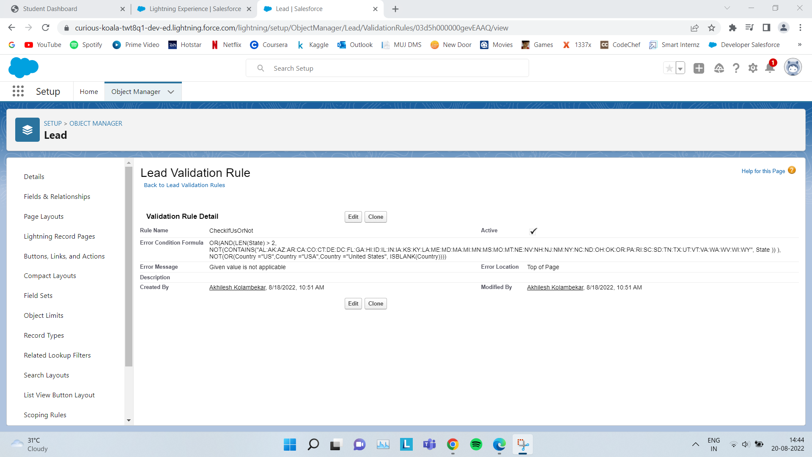

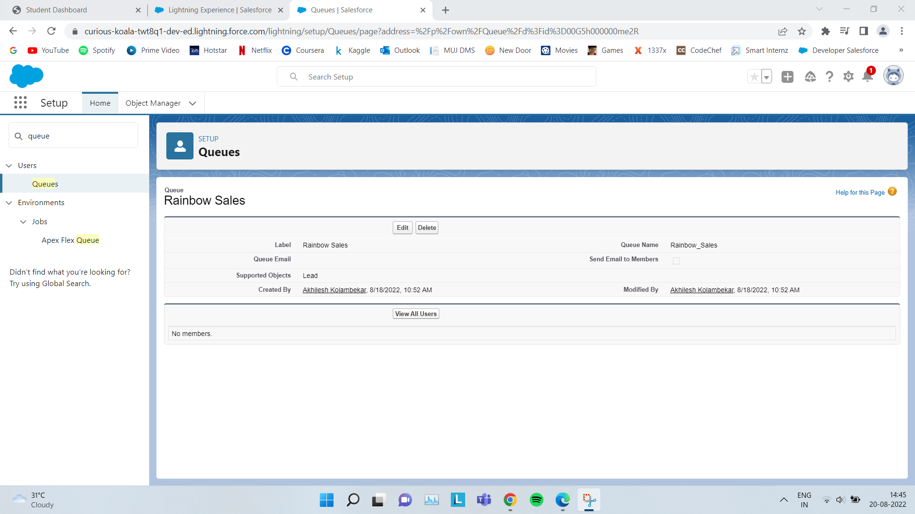

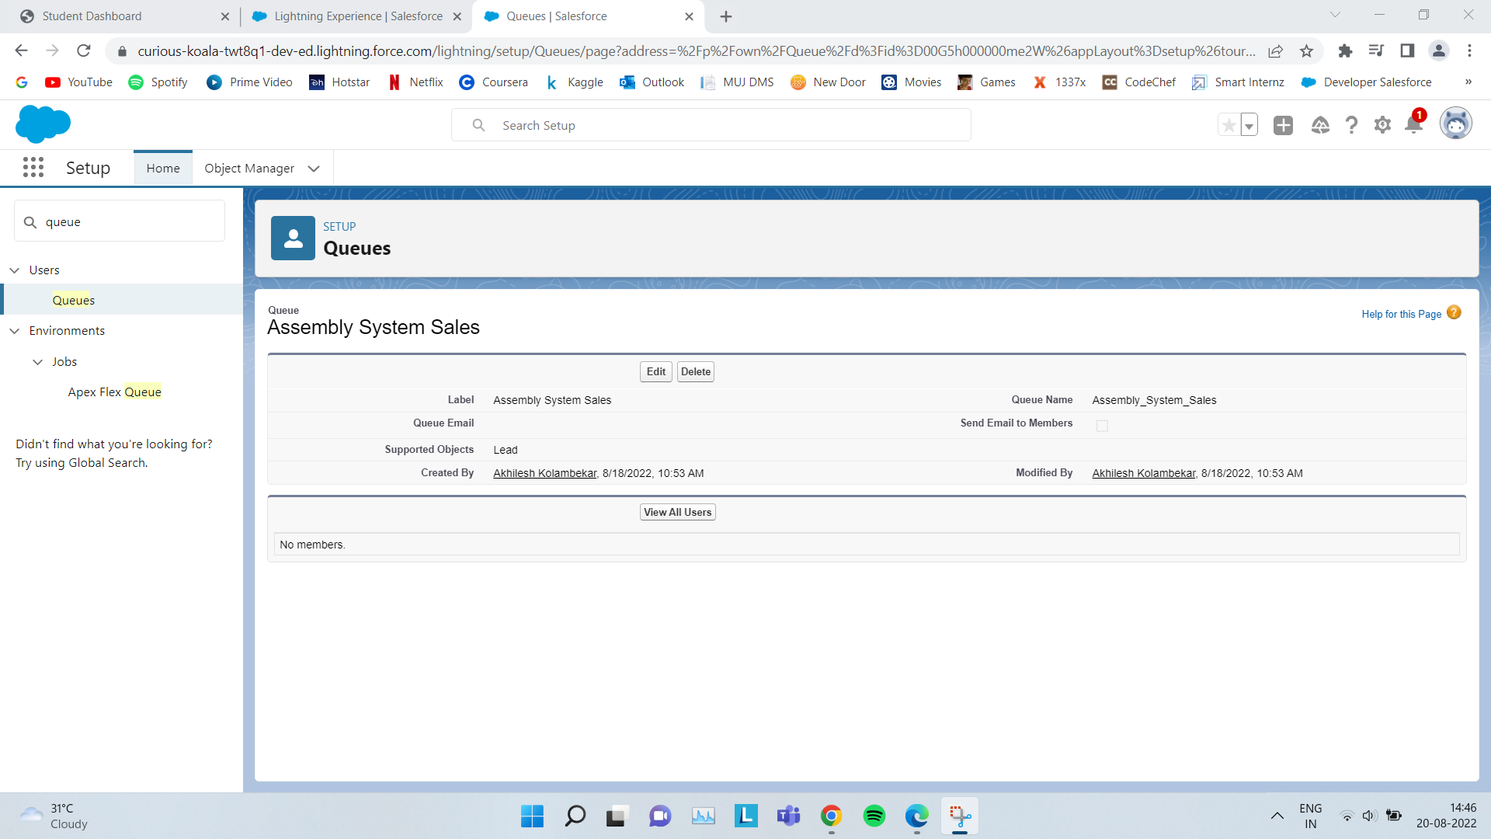

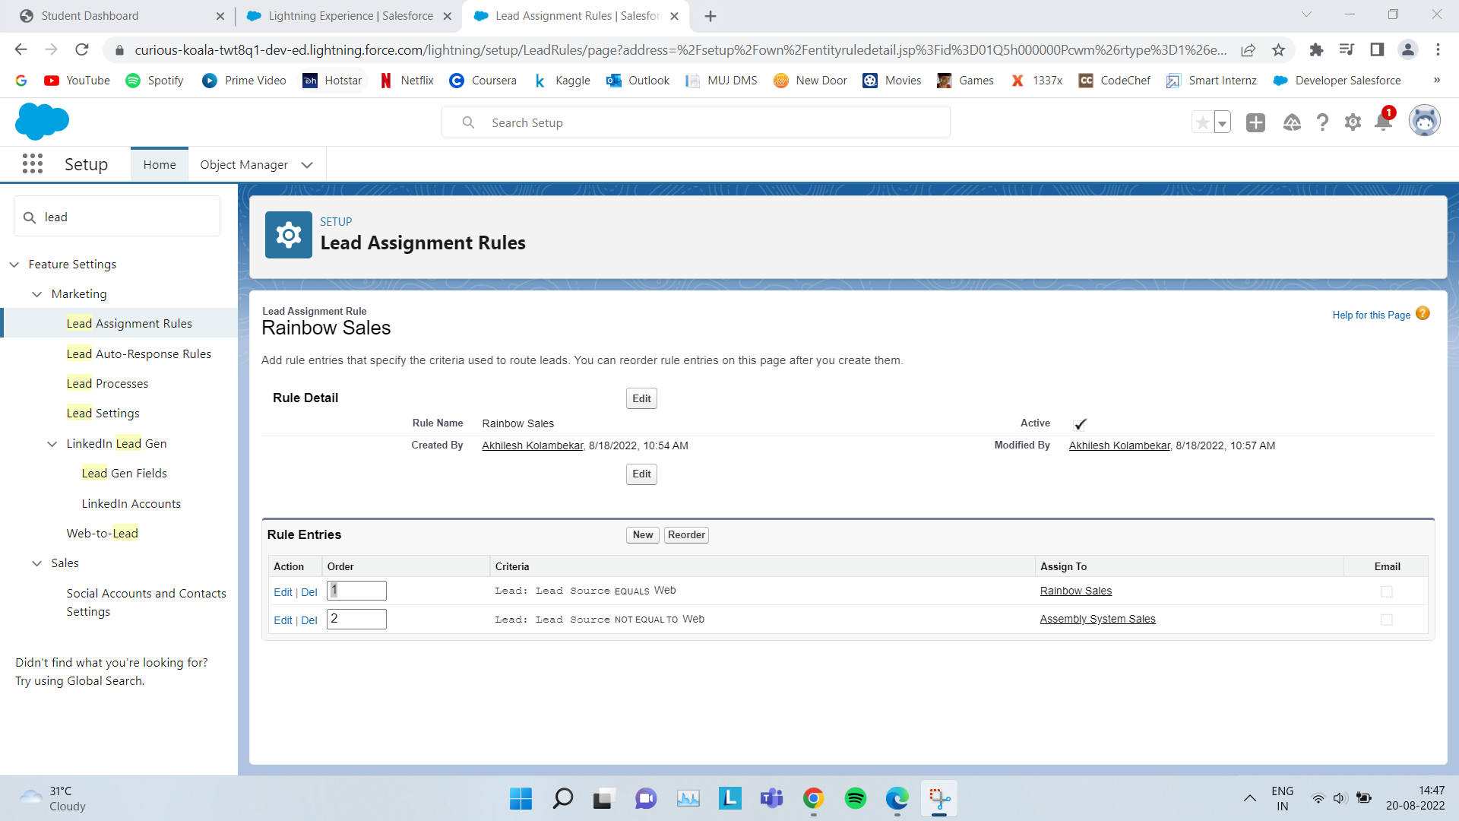

1. **Automate Accounts**

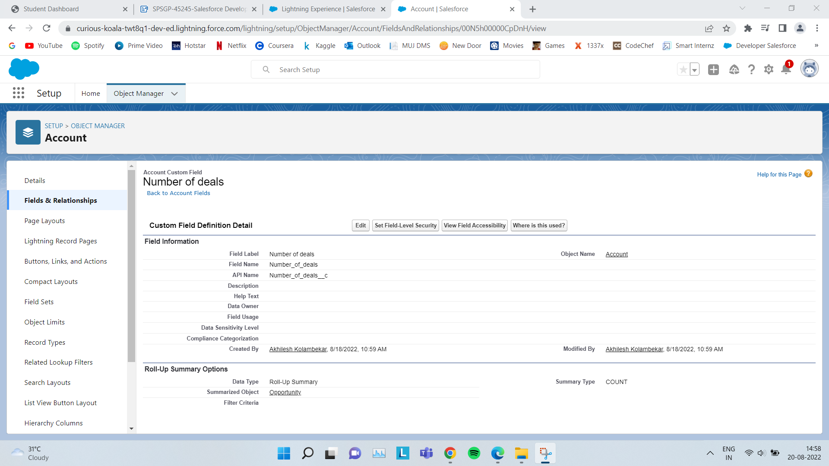

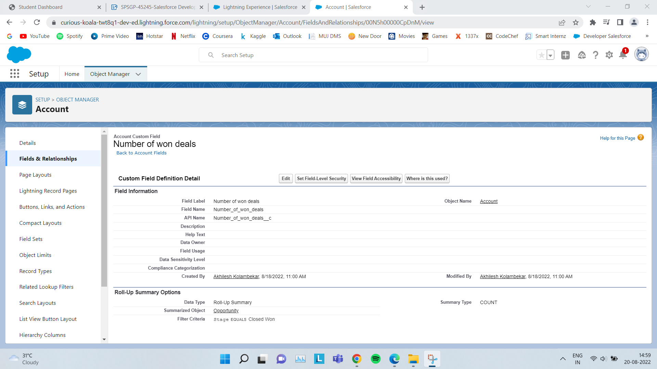

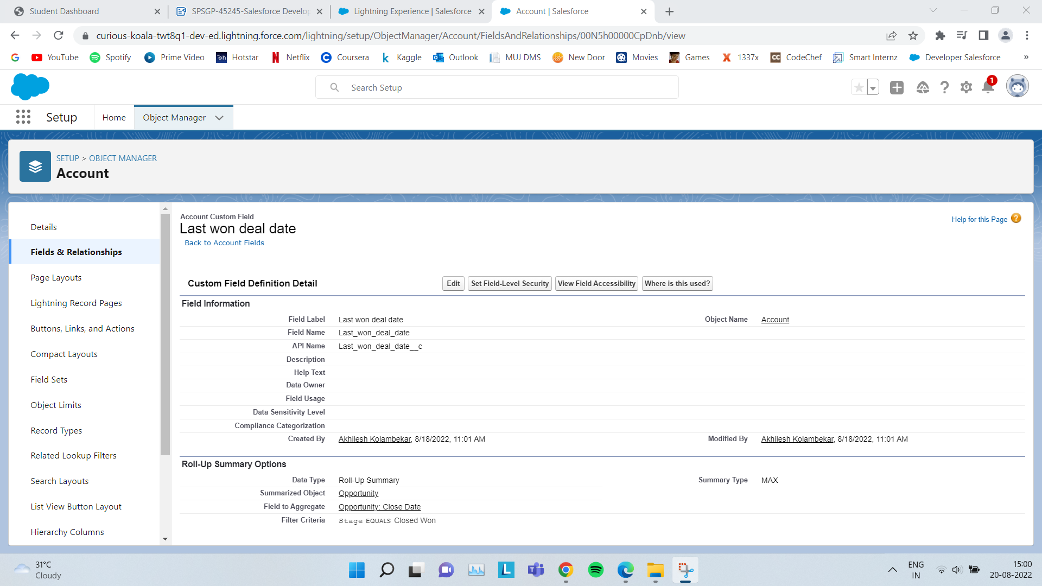

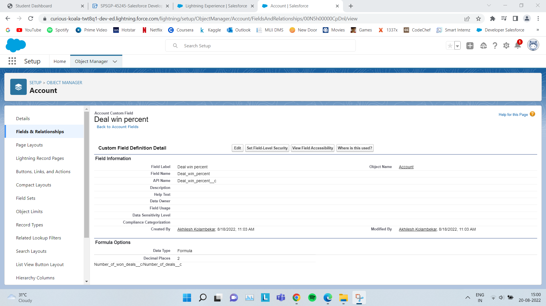

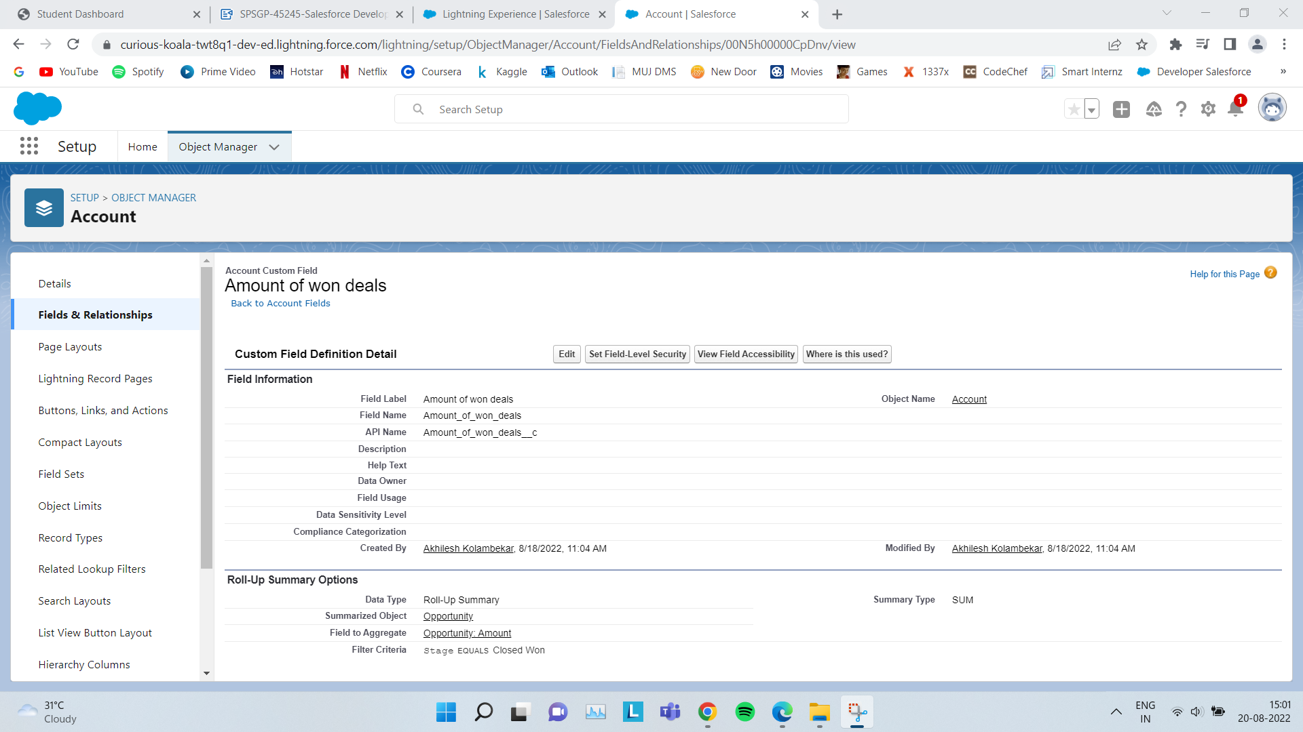

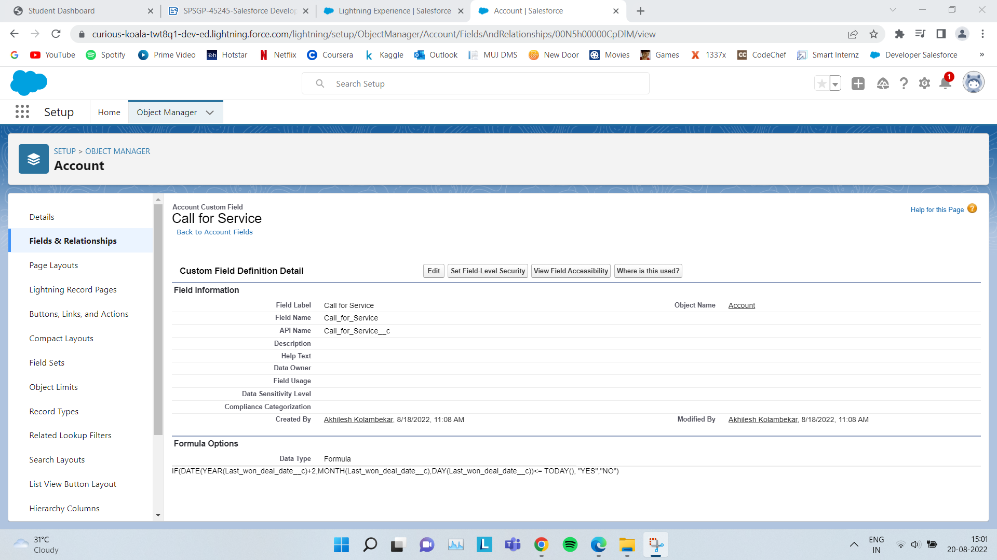

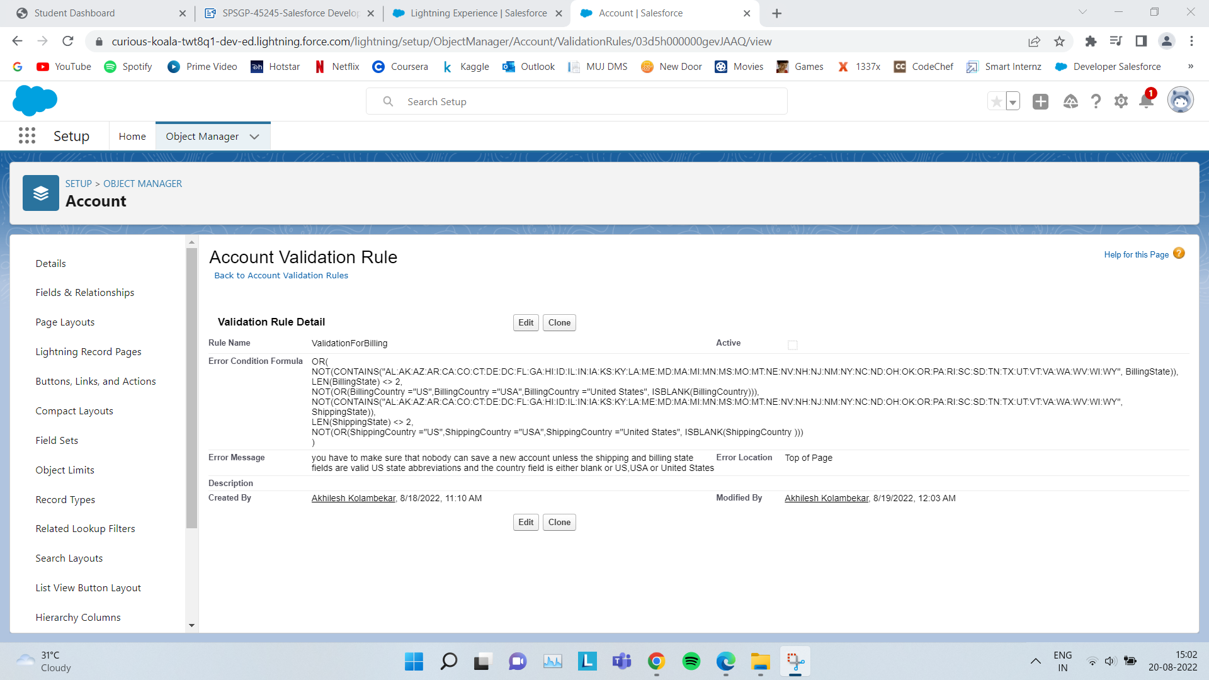

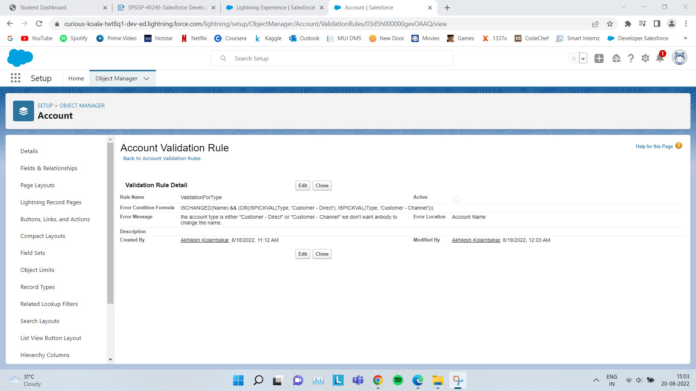

1. **Create Robot Setup Object**

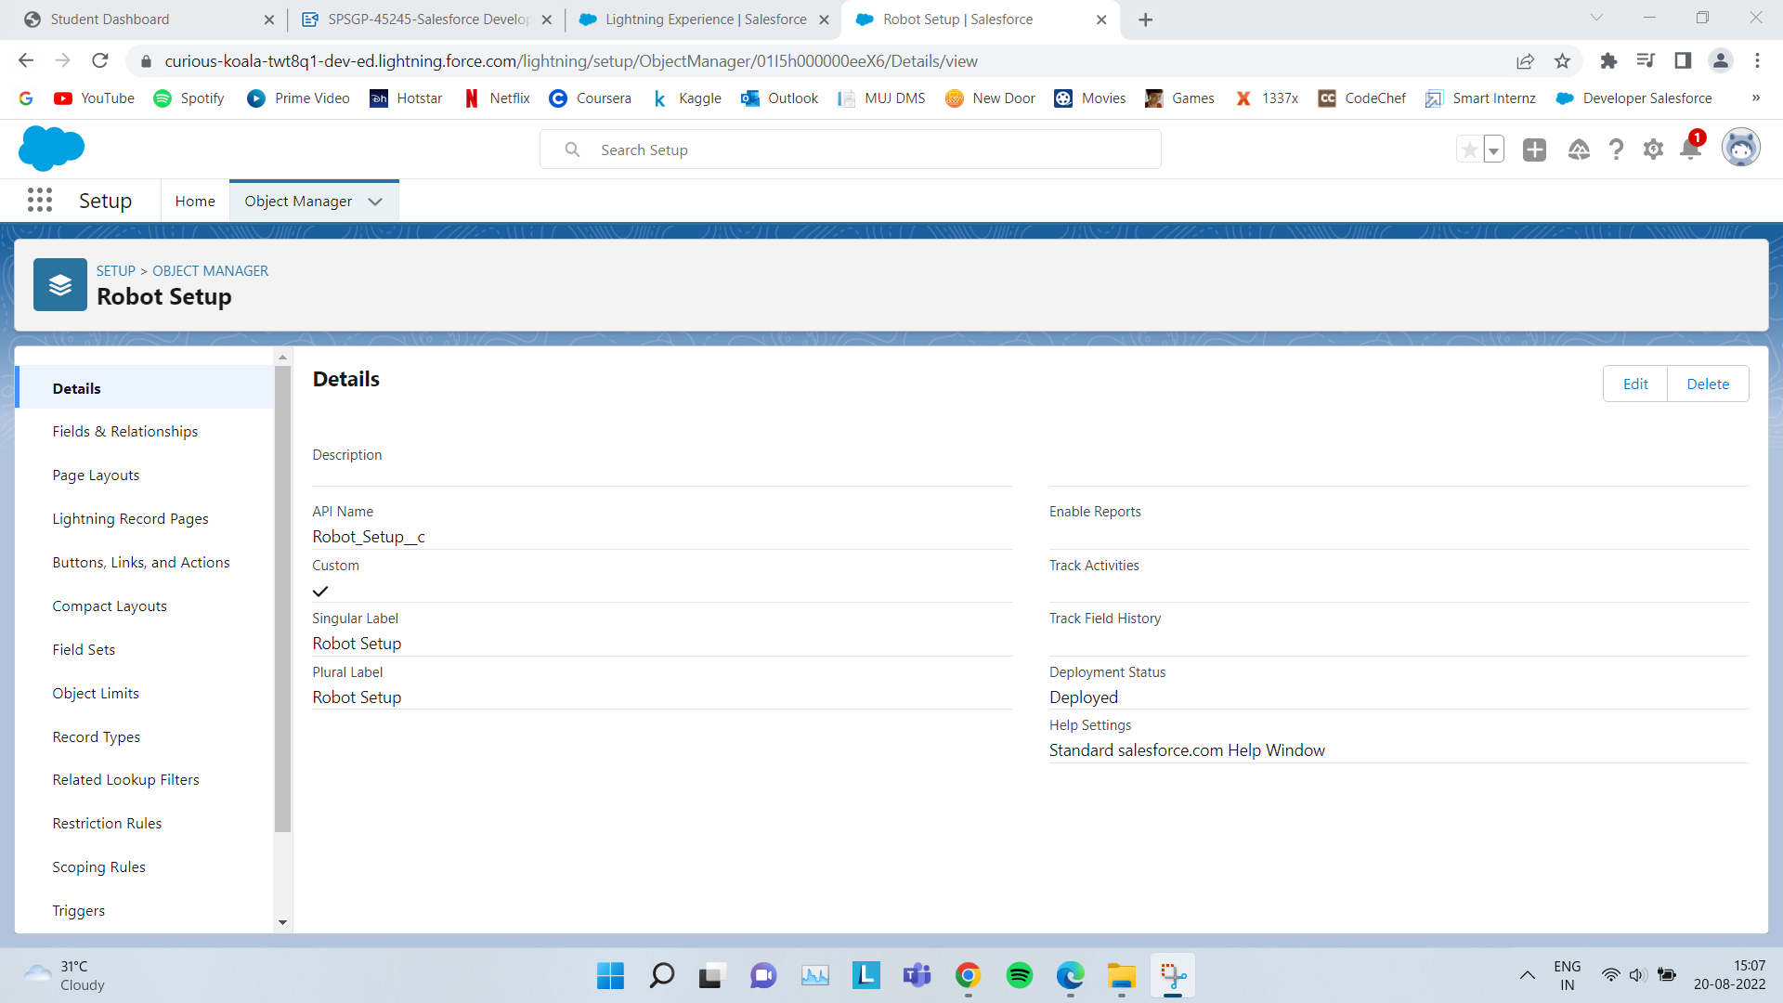

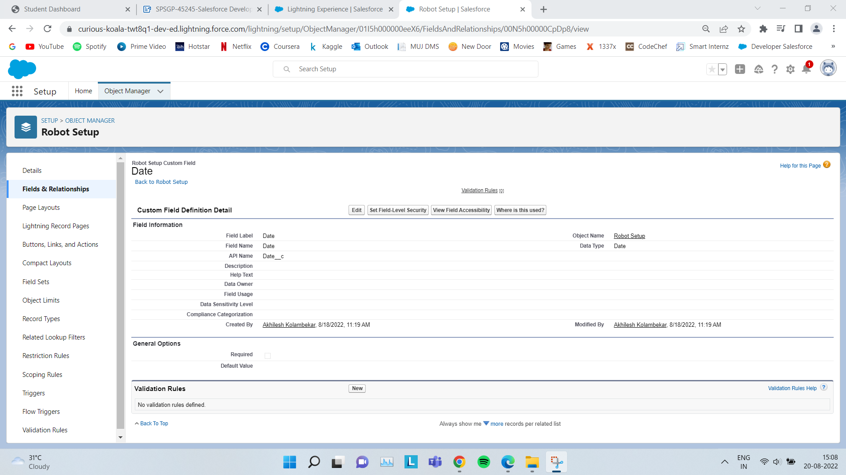

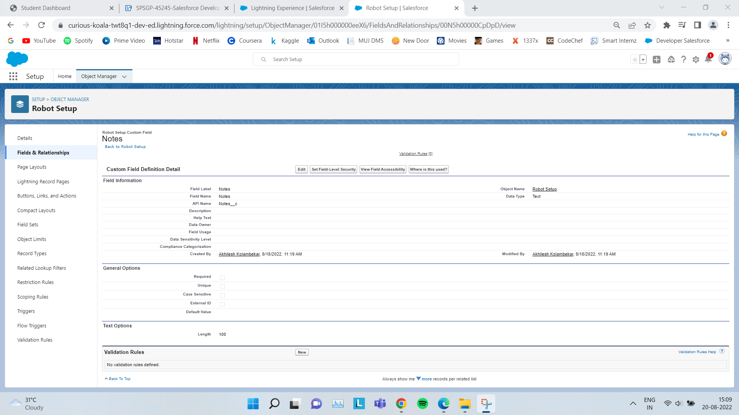

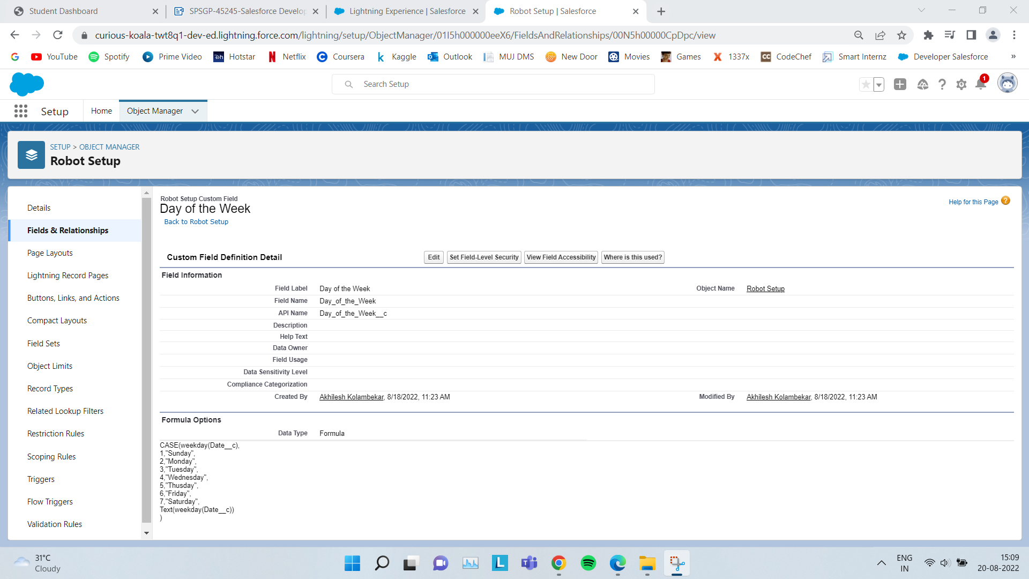

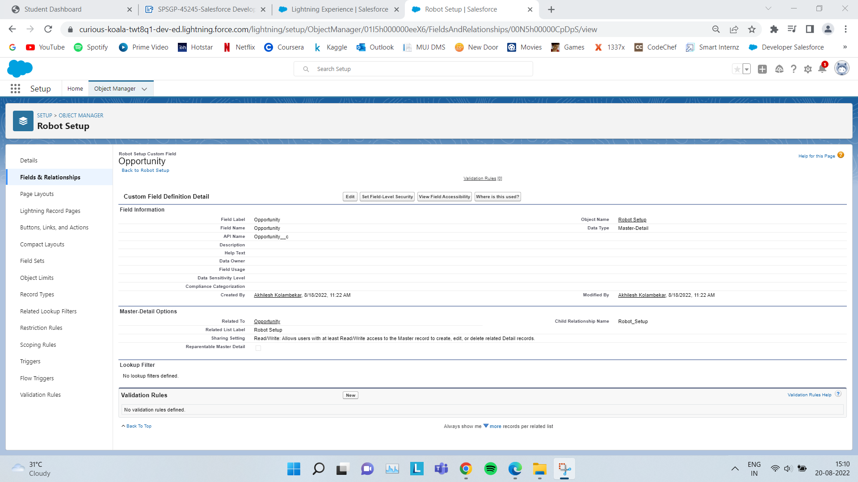

1. **Create Sales Process and Validate Opportunities**

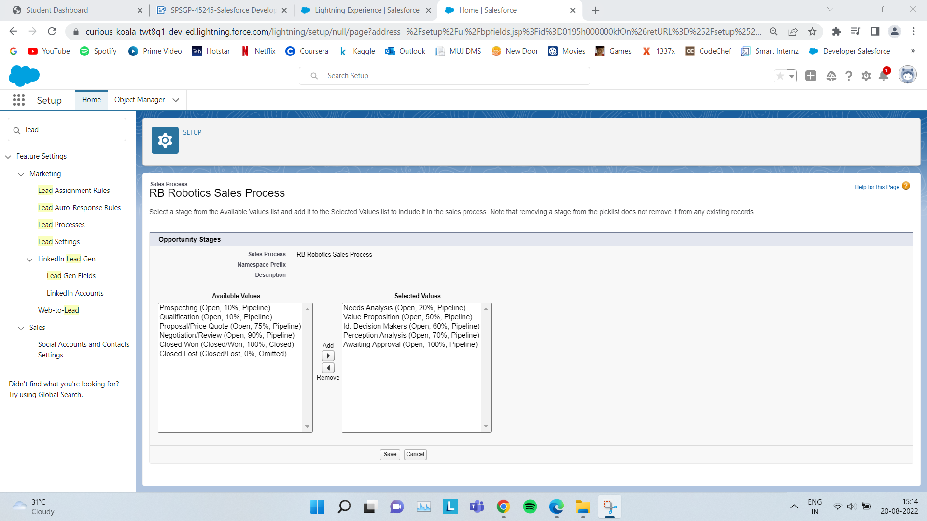

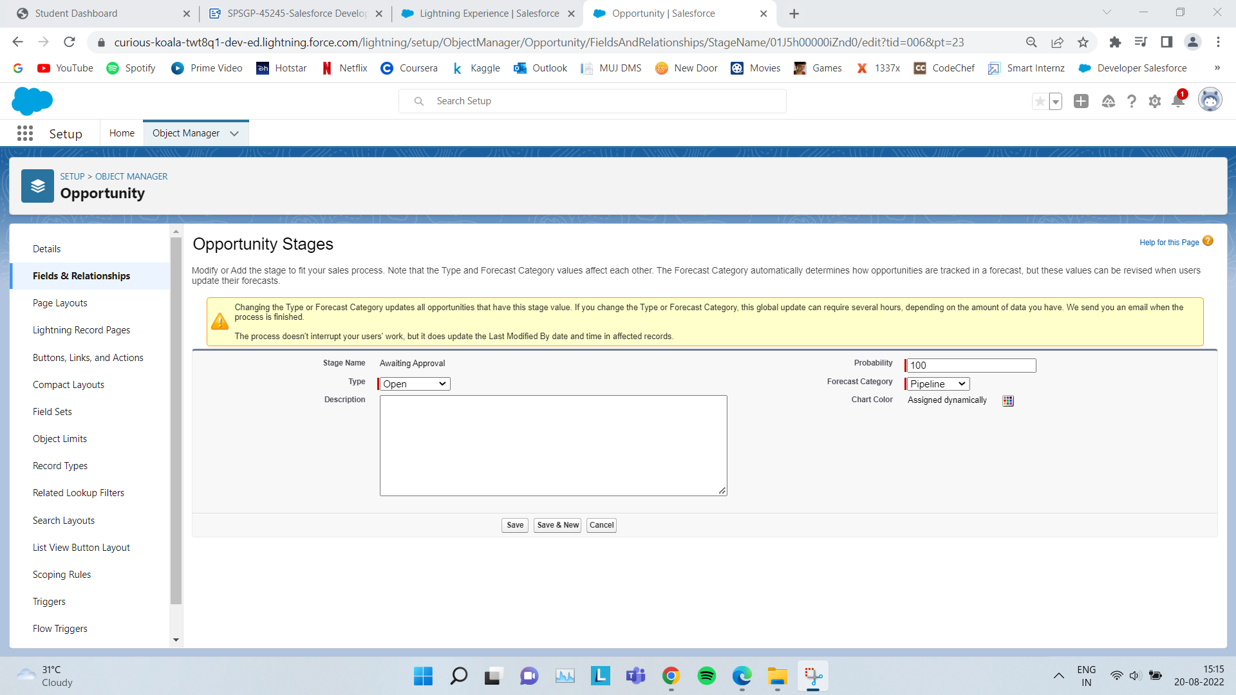

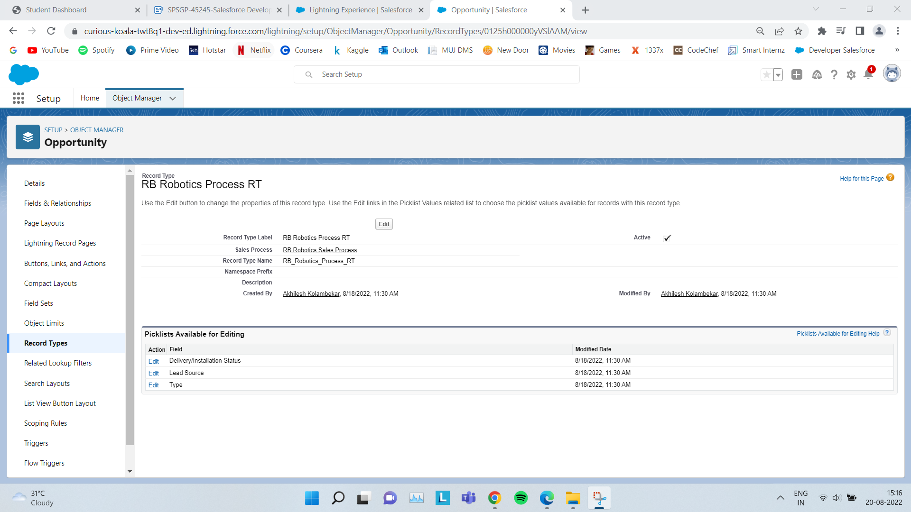

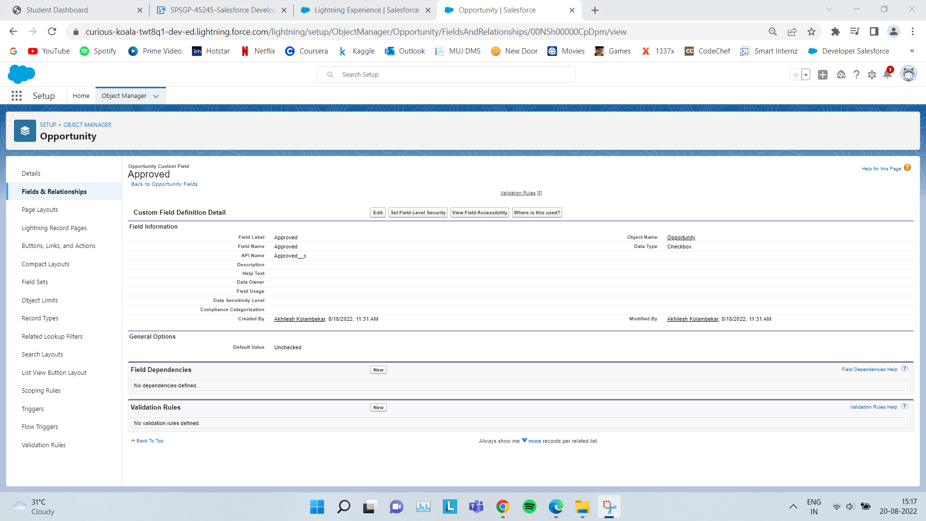

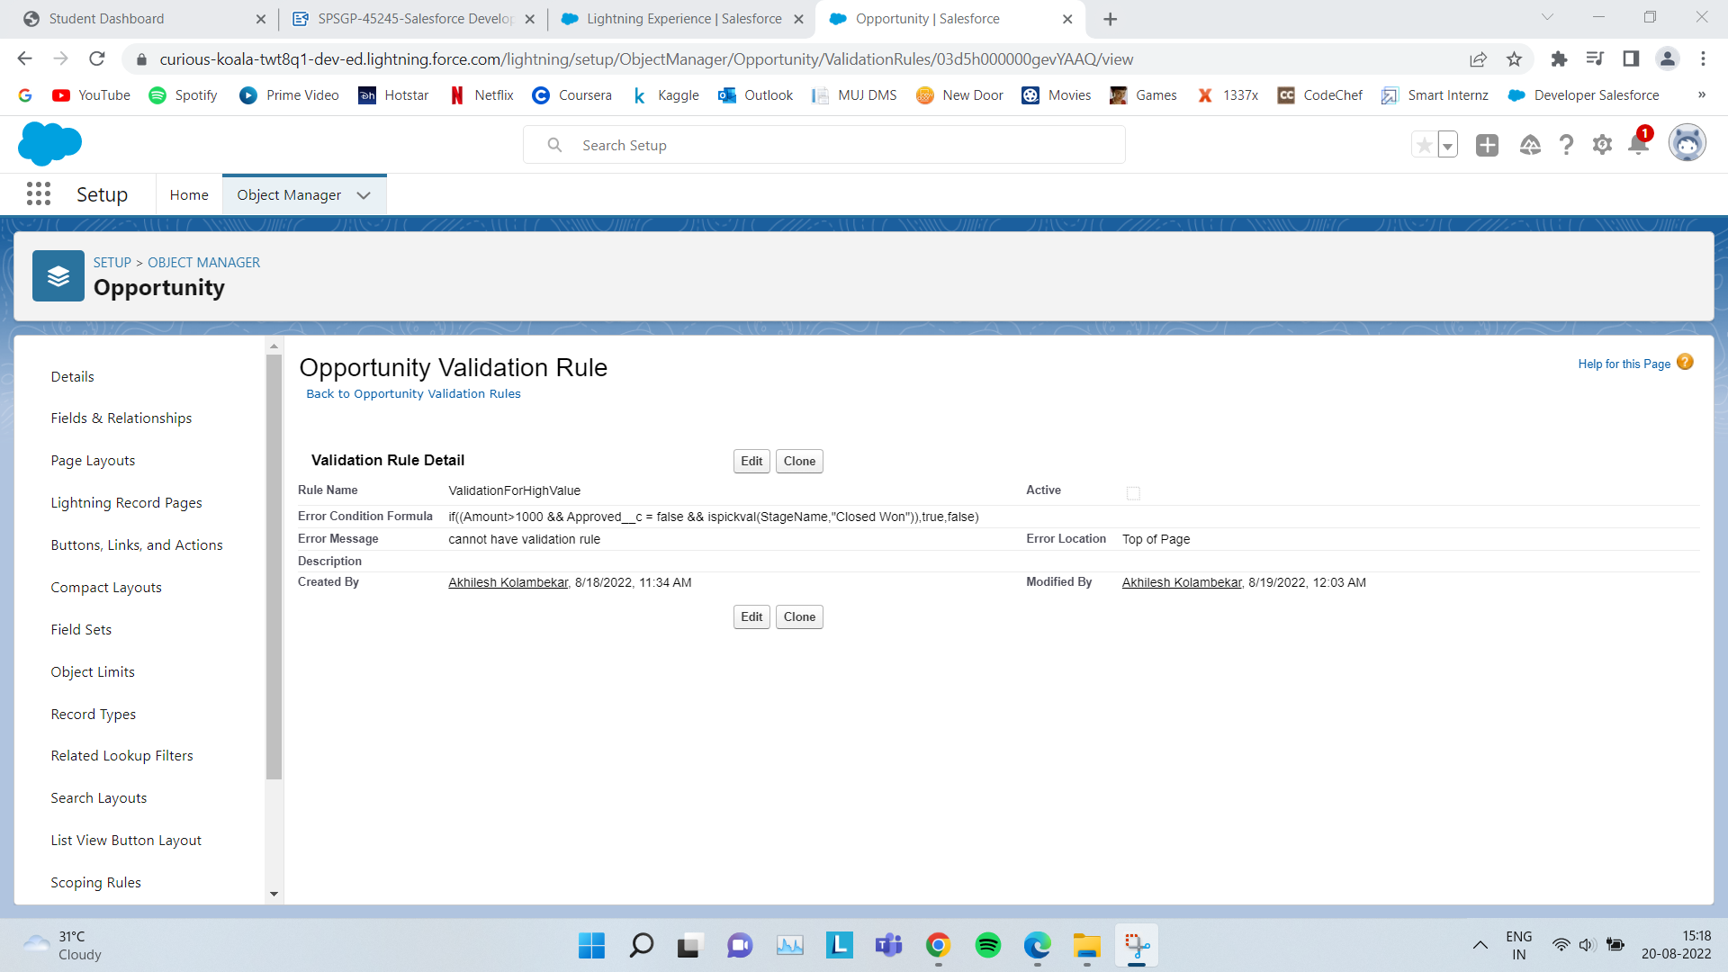

1. **Automate Opportunities**

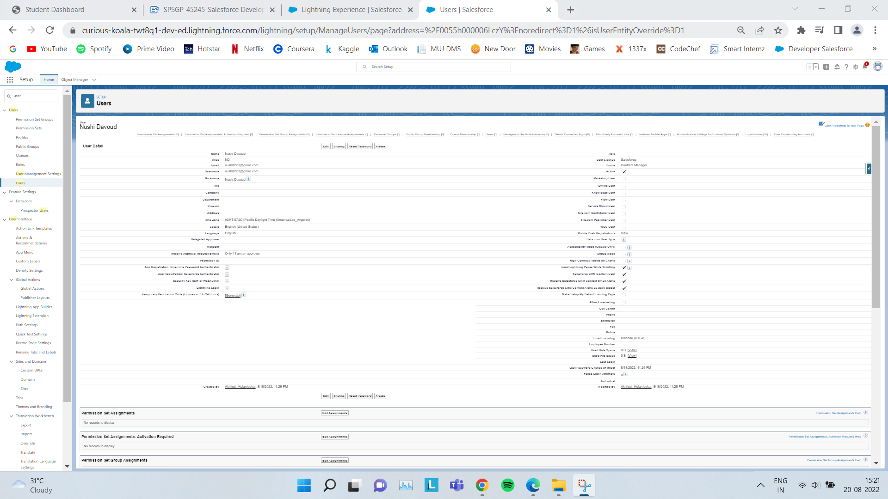

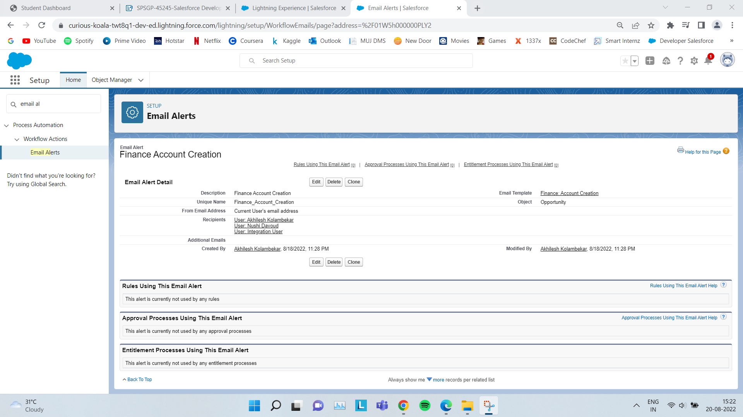

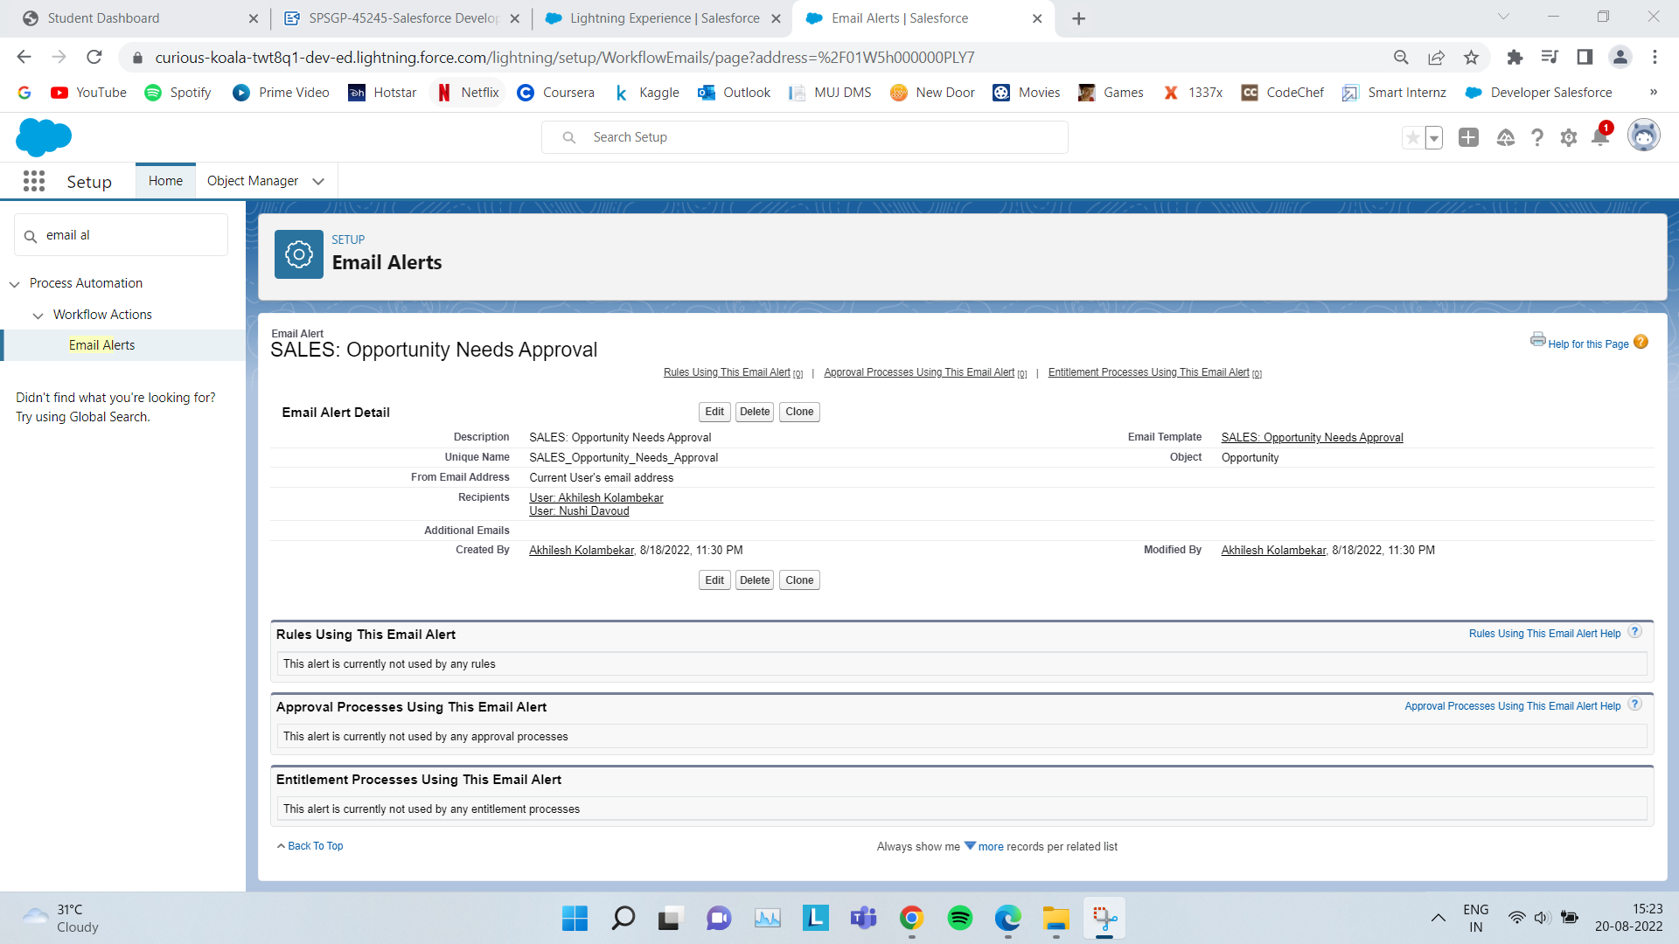

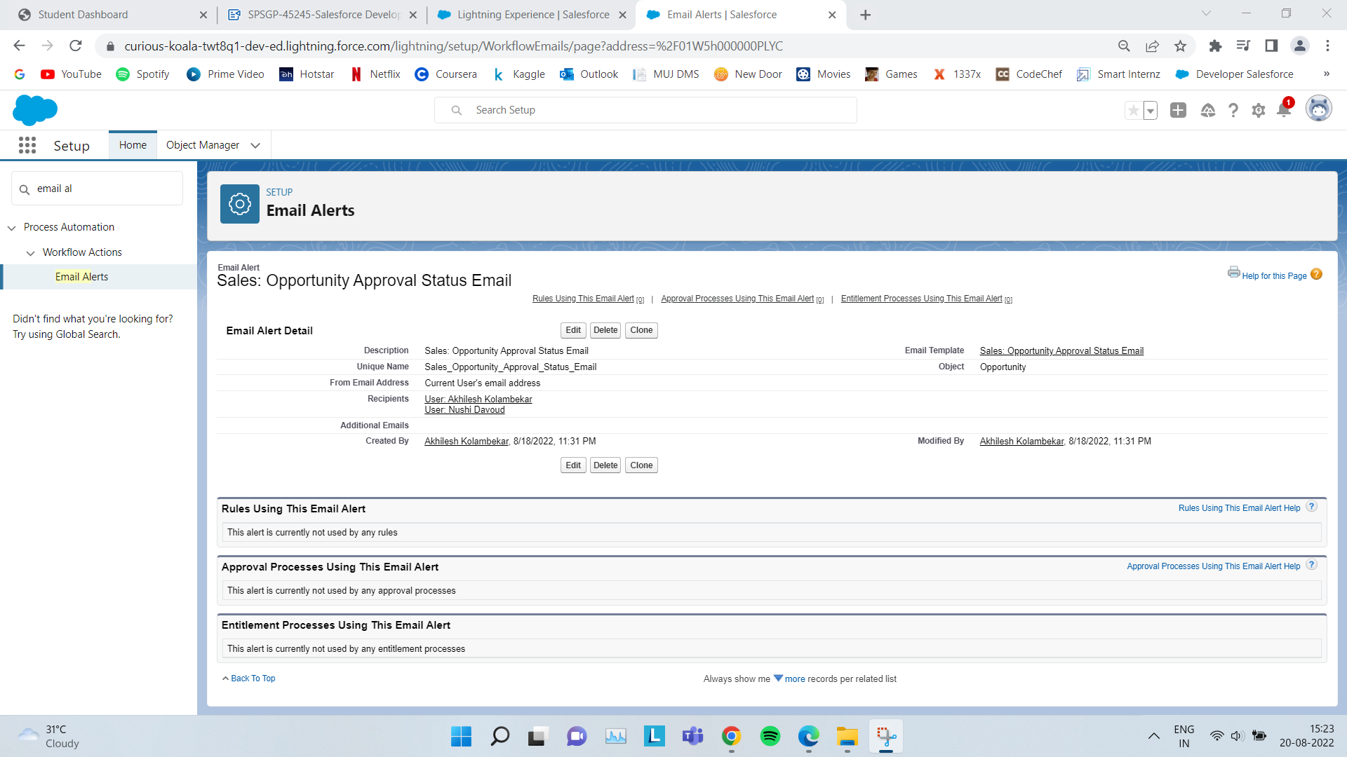

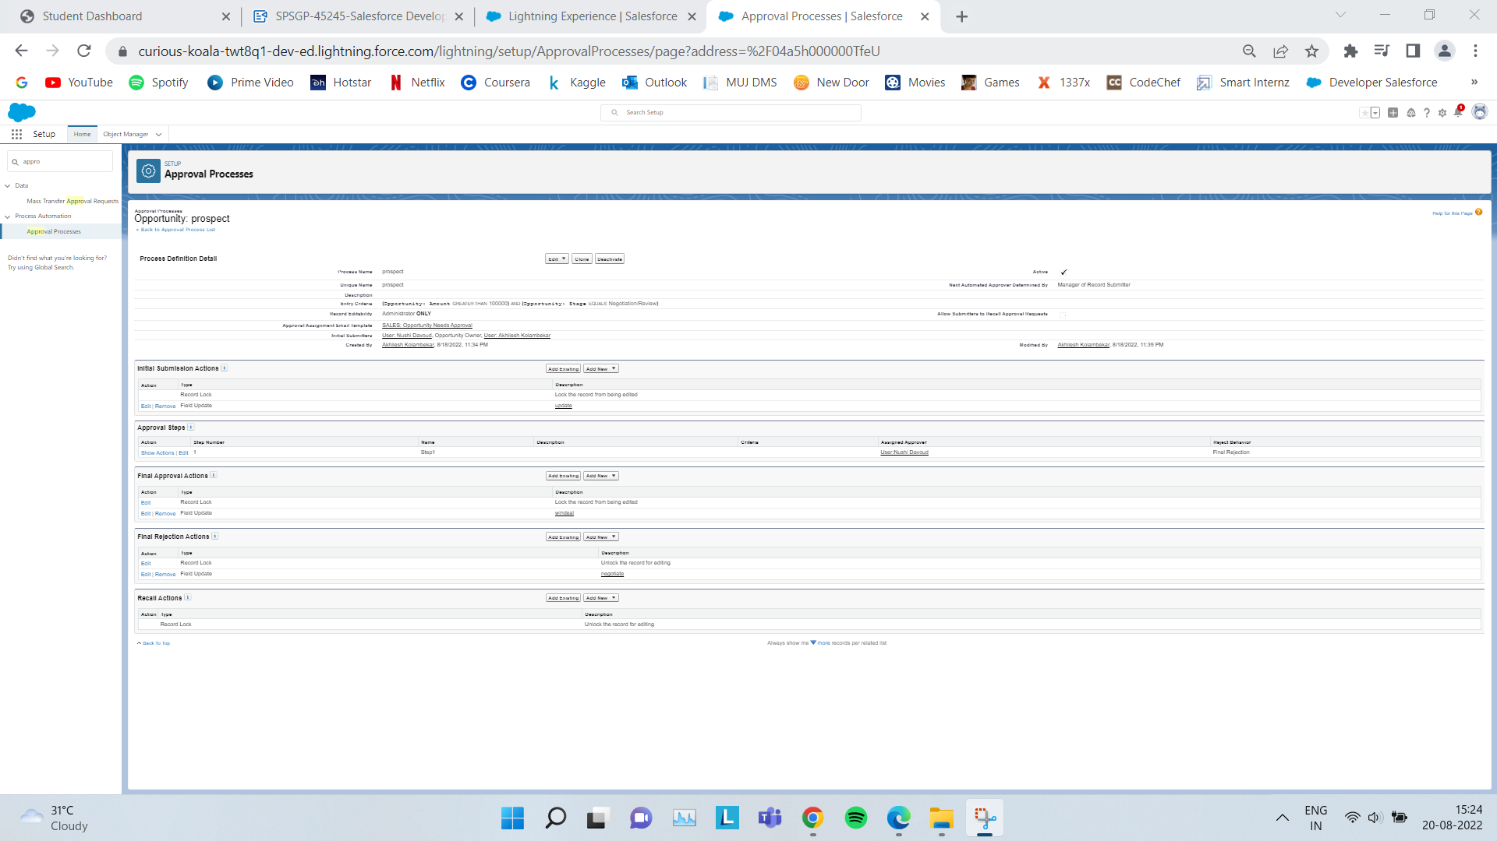

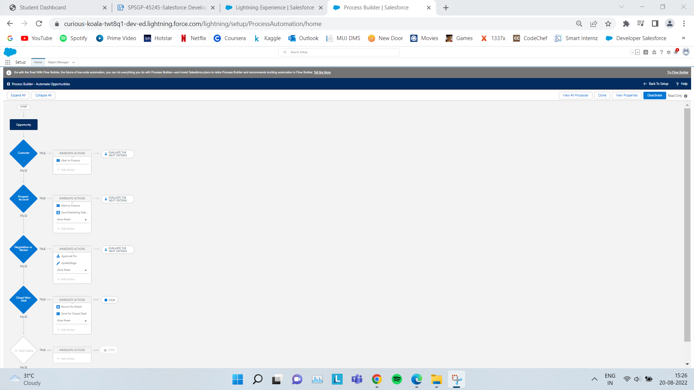

1. **Create Flow for Opportunities**

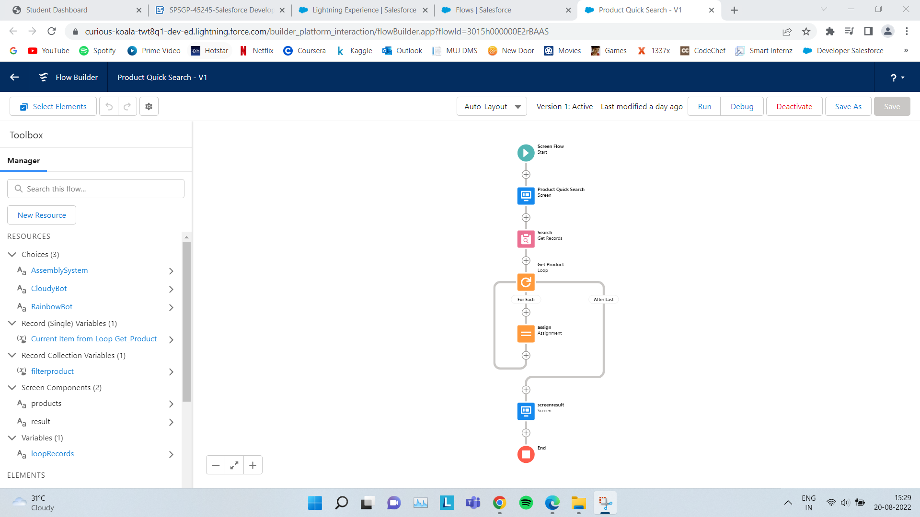

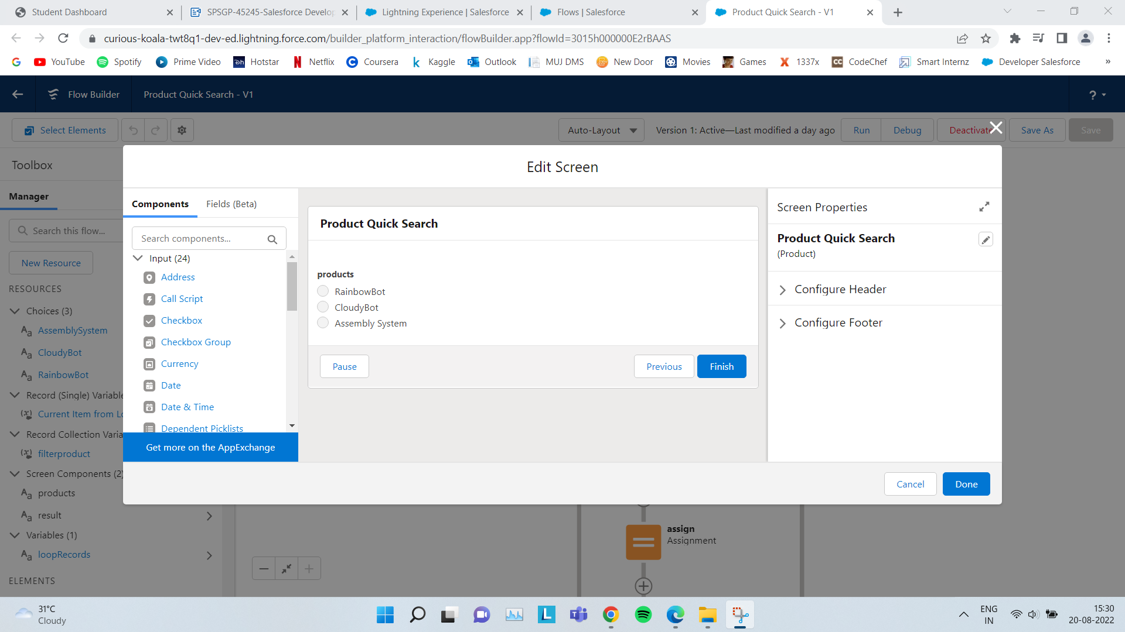

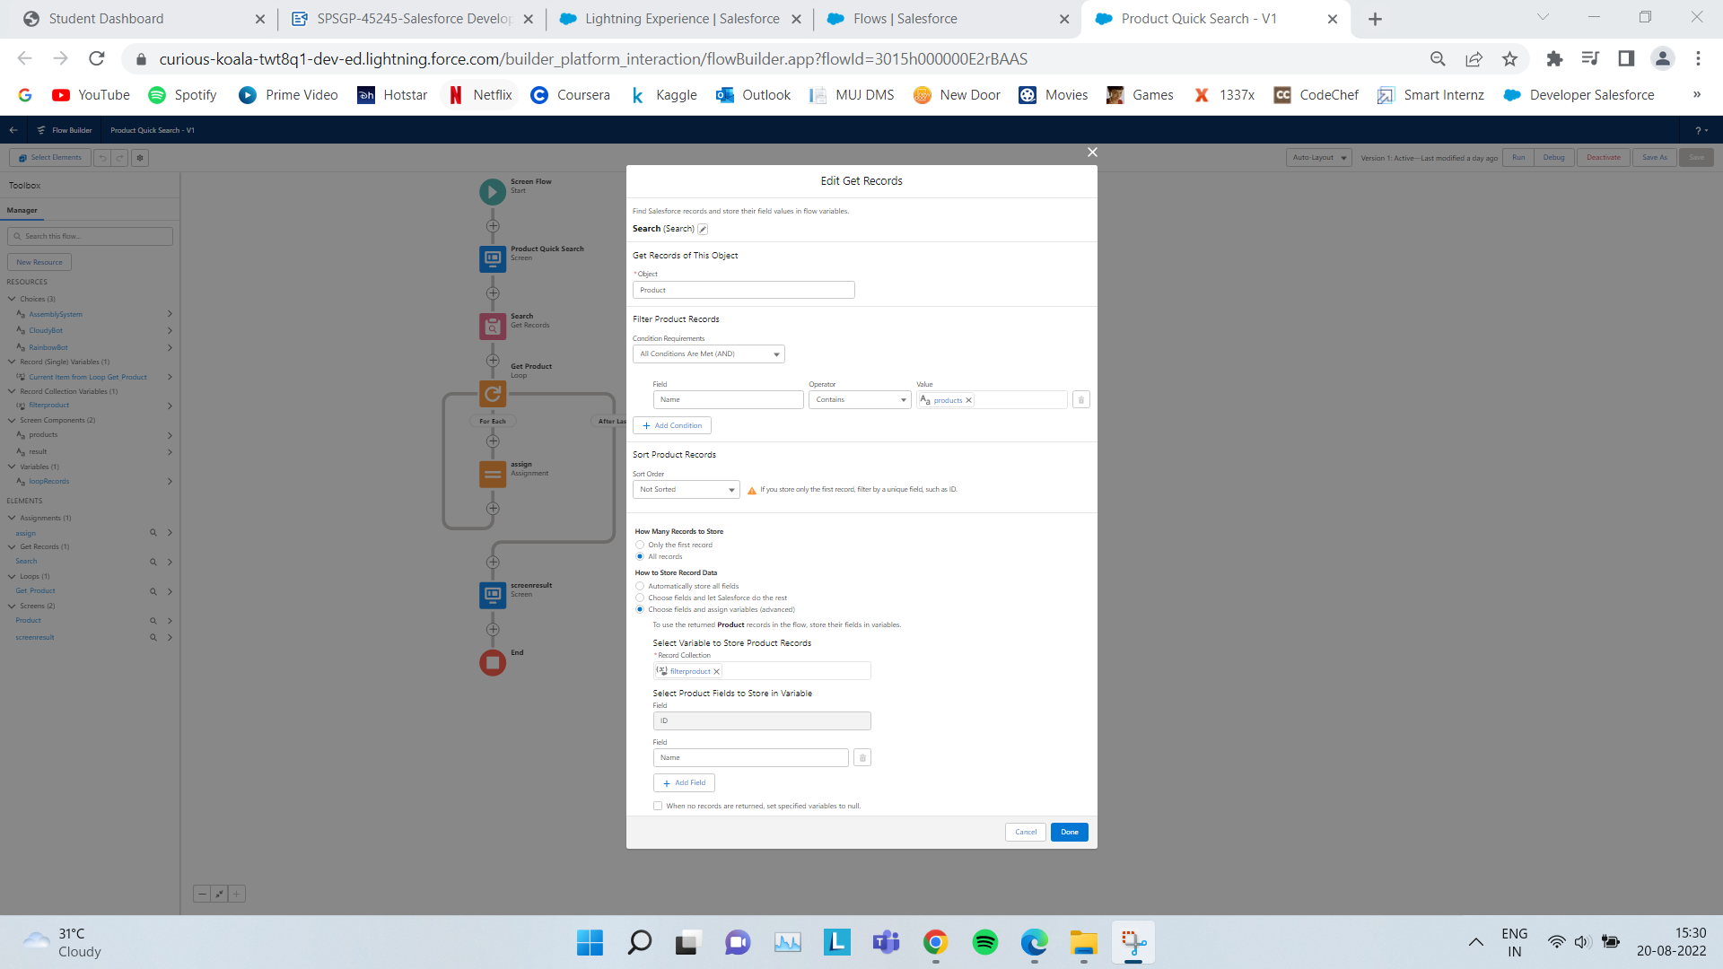

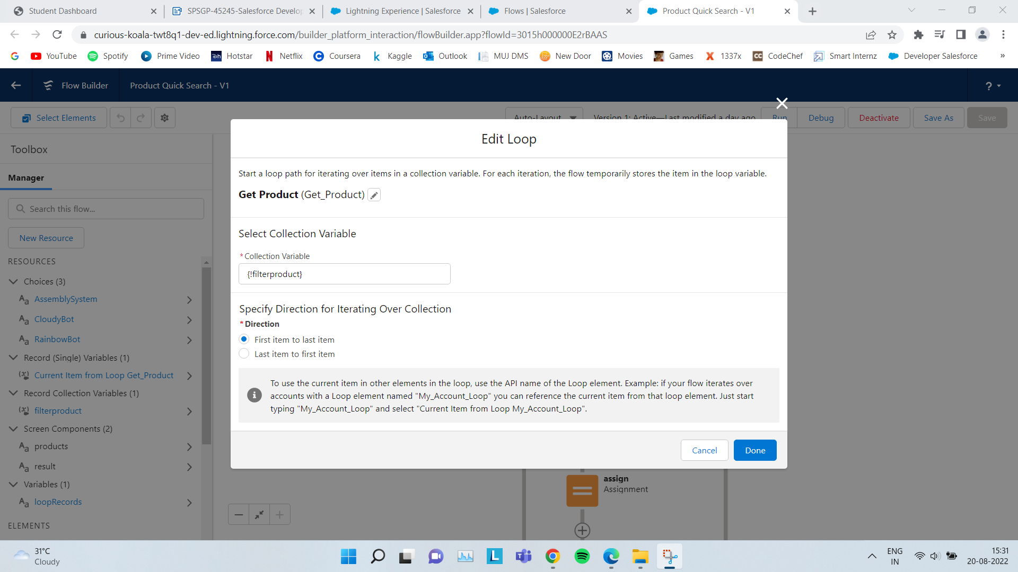

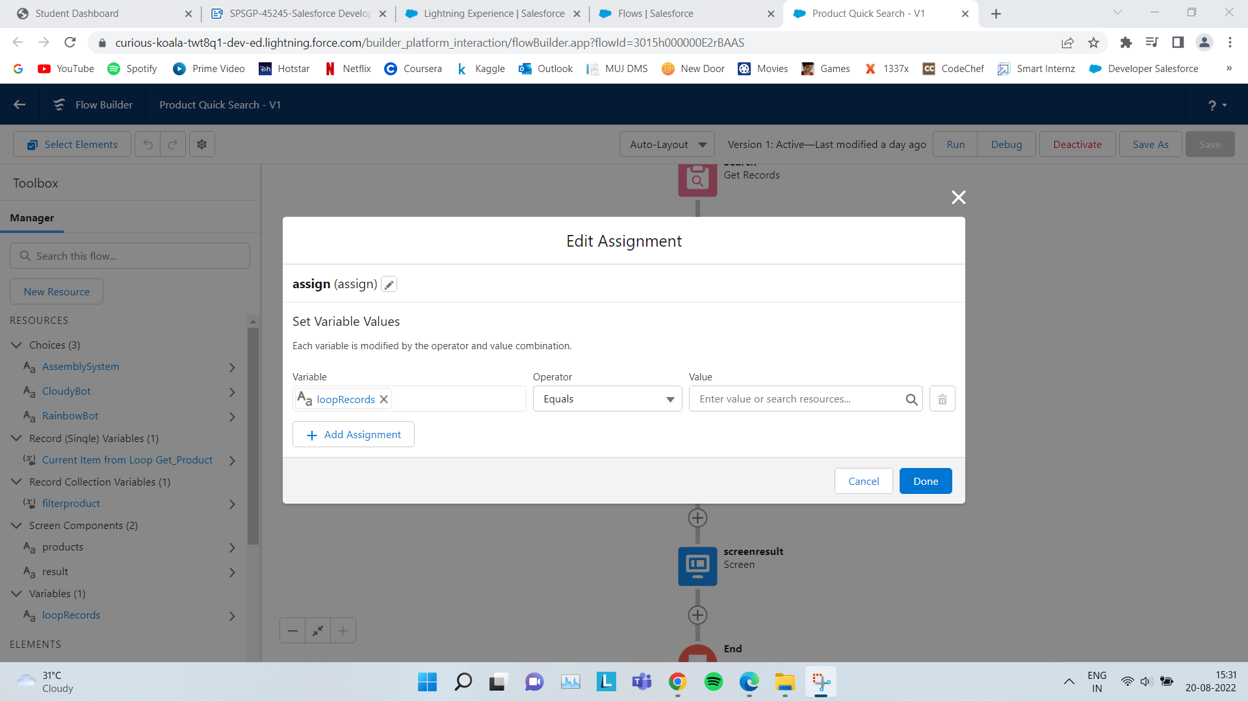

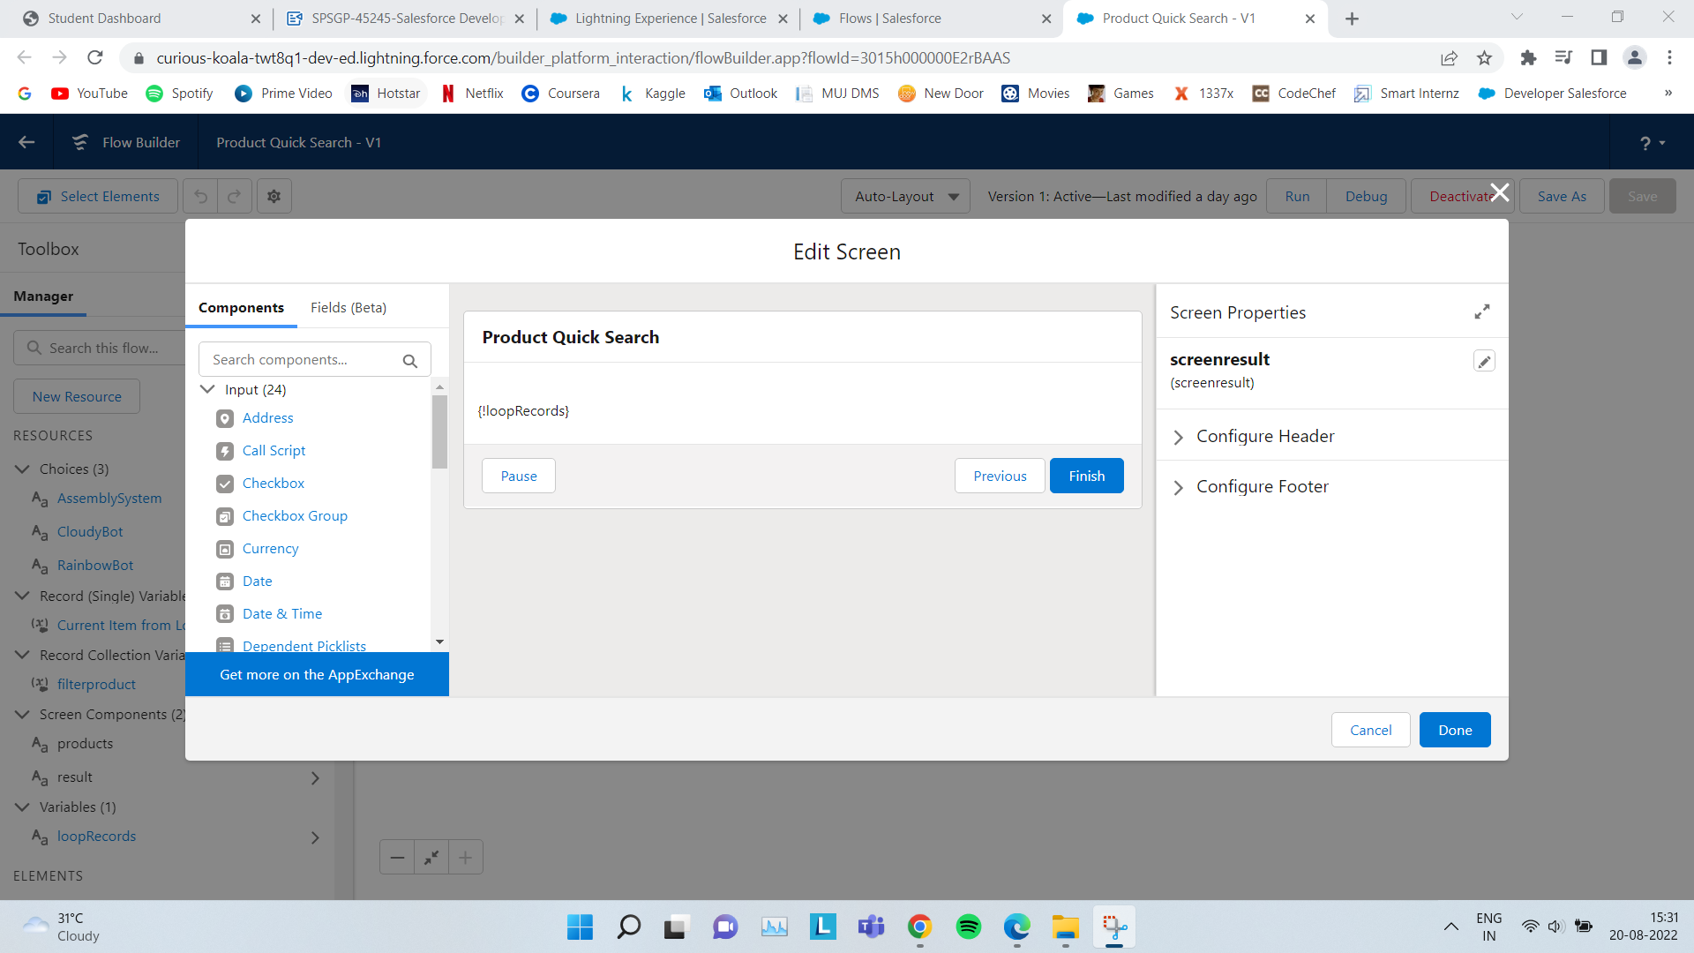

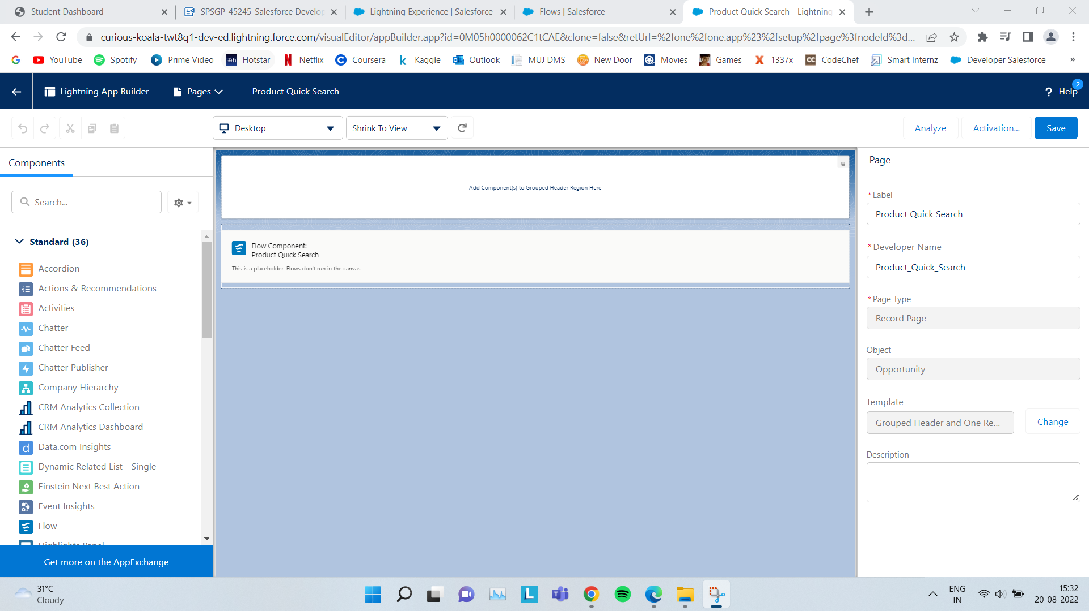

1. **Automate Setups**

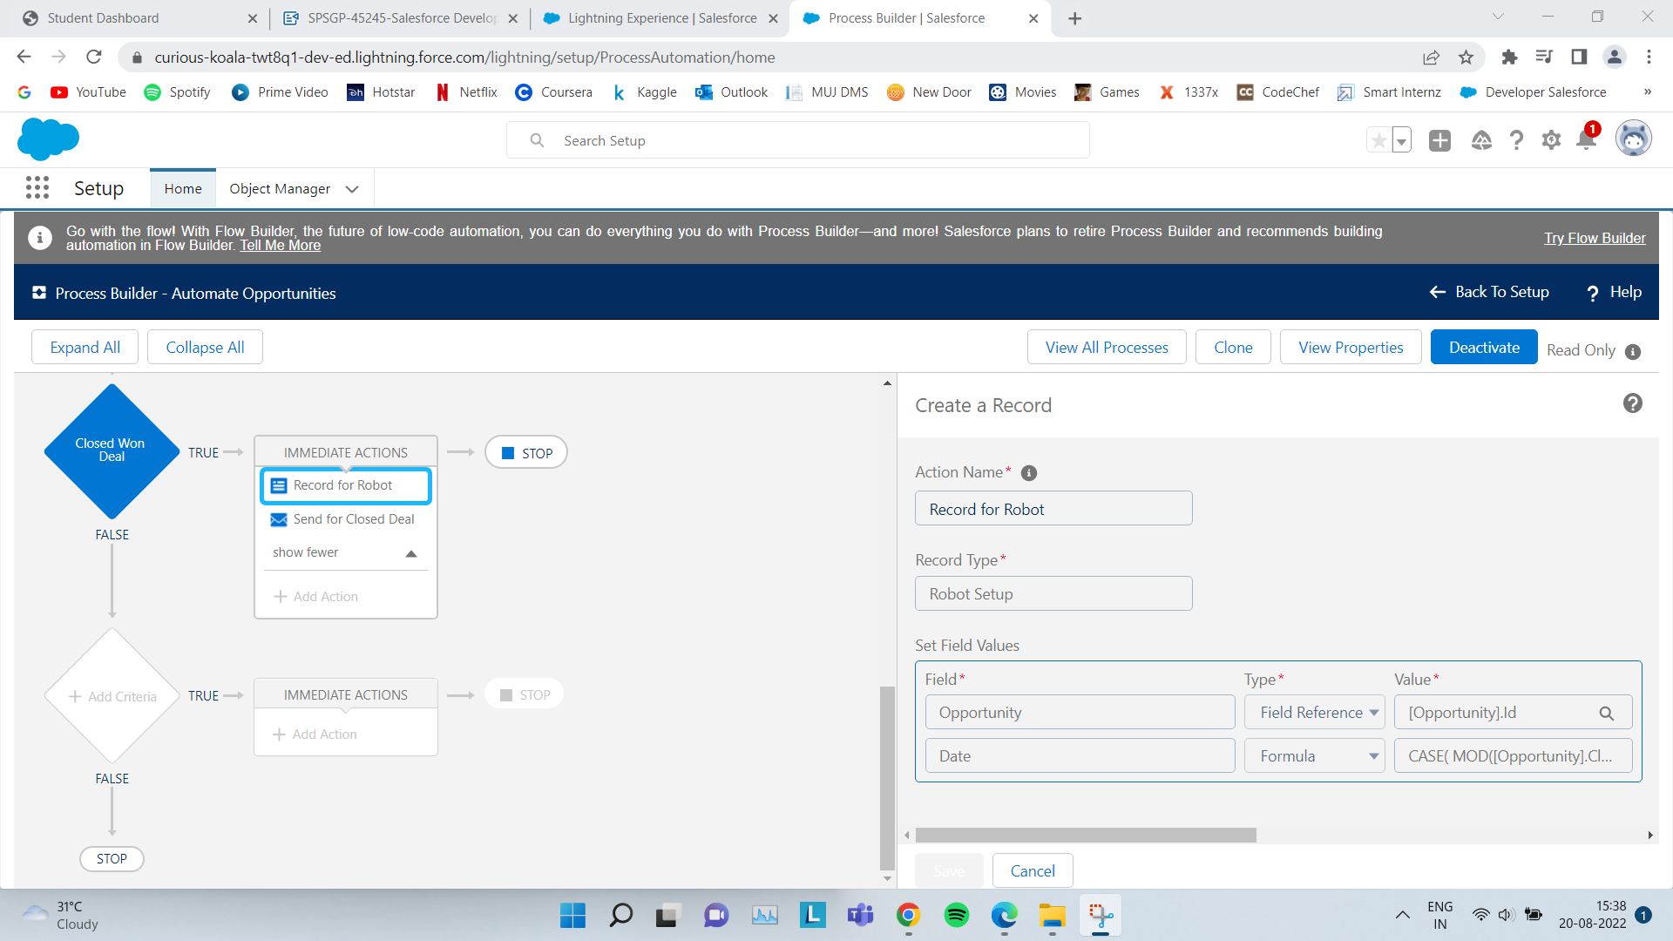

Value for field Date changed to :-

CASE(  
  
MOD([Opportunity].CloseDate + 180 - DATE(1900, 1, 7),7),  
  
 0, [Opportunity].CloseDate + 181,   
  
 6, [Opportunity].CloseDate + 182,   
  
 [Opportunity].CloseDate + 180  
  
)